-----------------------Day 10 Assignment--------------------------

1. --Write a function to Calculate the total stock value for a given category:

--(Stock value=ROUND(SUM(unit_price * units_in_stock)::DECIMAL, 2)

--Return data type is DECIMAL(10,2)

CREATE OR REPLACE FUNCTION get_stock_value_by_category(

p_category_id INT

)

RETURNS DECIMAL(10,2)

LANGUAGE plpgsql

AS $$

DECLARE

v_stock_value DECIMAL(10,2);

BEGIN

SELECT ROUND(SUM(unit_price * units_in_stock)::DECIMAL, 2)

INTO v_stock_value

FROM products

WHERE category_id = p_category_id;

RETURN COALESCE(v_stock_value, 0.00);

END;

$$;

SELECT get_stock_value_by_category(7);

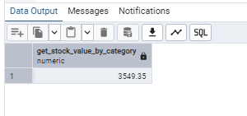

select *from products where category_id =7

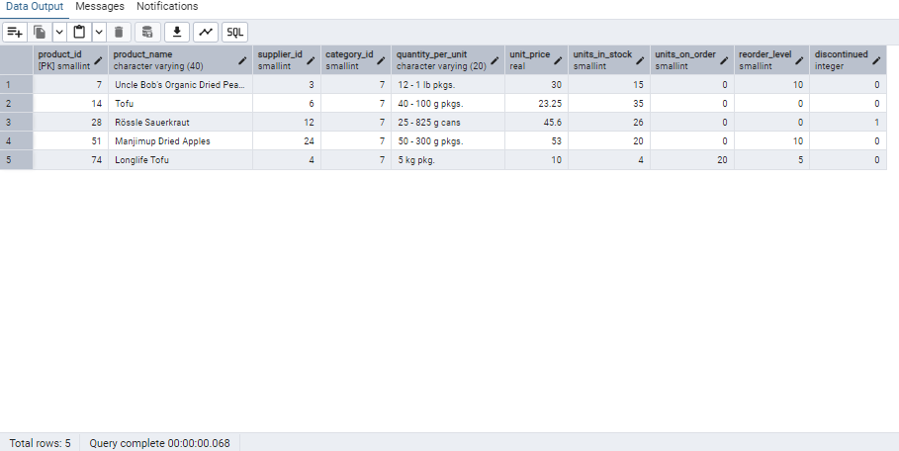

select count(*), unit_price , units_in_stock

from products

where category_id =7

group by unit_price , units_in_stock ;



